3d leisure Gender Pay Gap Report 2026

- Introduction
All UK companies with over 250 employees are required to publish their gender pay gap data on an annual basis which measure the average earnings of all male and female employees, regardless of role, seniority and working hours and show the percentage difference between the two. The report is a snapshot of data as of 5 April 2025.
- Findings
The Gender Pay Gap is defined as the difference between the mean or median hourly rate of pay of men and women. The mean gender pay gap is the difference between the average hourly earnings of men and women. The median hourly pay gap is the difference between the midpoints in the ranges of hourly earnings of men and women.

3d leisure’s Gender Pay Gap
Differences in Gap | Mean - 2025 | Median - 2025
Gender pay gap | -1.12% | 0.37%

The average difference in pay (the mean) is -1.12%, which means that women earn about 1.12% more than men on average.
The middle value (the median) of the pay gap is only 0.37%, meaning that in many cases, there’s almost no difference in pay between men and women.
This year, the company’s mean gender pay gap has shifted to -1.12%, compared to 9.30% last year. Previously, men were earning more than women on average; this year, the gap has reversed slightly, with women earning marginally more than men on average. Overall, this represents a significant positive movement toward pay equity. The median gender pay gap has remained minimal, with the current gap standing at just 0.37%, compared to -0.05% last year. This suggests that for many workers in the middle of the pay distribution, men and women are earning nearly the same amount, reflecting a positive trend and a great achievement.
3d leisure’s Bonus Gender Pay Gap
Proportion of males receiving bonus payments: 15.72%
Proportion of females receiving bonus payments: 21.24%

Differences in Gap | Mean - 2025 | Median - 2025
Bonus gender pay gap | 47.01% | 0.00%

A higher proportion of females (21.24%) receive bonus payments compared to males (15.72%), suggesting more women are eligible for bonuses, which may be due to the higher female representation in the workforce across the four quartiles. However, while the median bonus pay gap shows no disparity (0.00%), indicating equal pay for equal work at the middle point, the mean bonus pay gap reveals that women earn, on average, 47.01% less than men in bonus payments. This suggests that while women are represented equally in the middle of the bonus distribution, men tend to receive larger bonuses overall.
Pay Quartiles
The graphs below show the proportion of men and women employees within our workforce as of 5 April 2025 divided into four pay band quartiles; lower, lower middle, upper middle and upper.

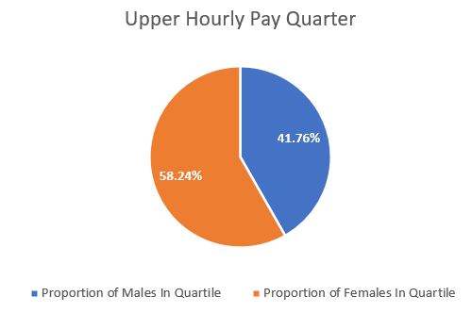
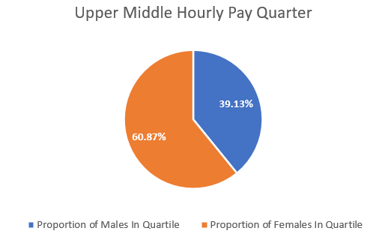
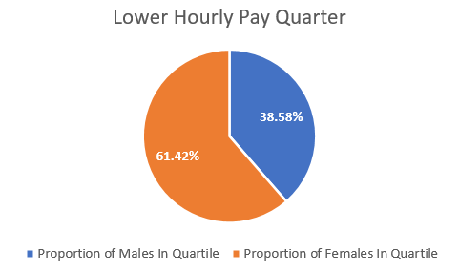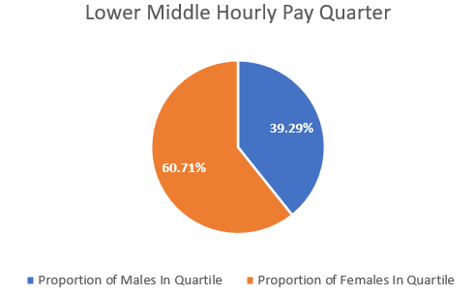

Comparing to last year, we can see that women's representation has slightly increased in the upper pay band, but their presence in the lower and lower middle bands has also marginally increased too. The data highlights a trend towards more gender balance in the higher-paying quartiles, although women still predominantly occupy the lower pay bands. Some roles have traditionally attracted more male or female applicants (for example administrative positions attracting more female applicants) but we are working to challenge this, one vacancy at a time.
Moving forward, maintaining a positive shift in the very upper quartile, while continuing to improve gender equity in the lower bands, will be important steps towards achieving a more balanced workforce across all pay levels. The focus will sit on ensuring equal representation within the regional and board level.
- Action Plan
Moving forward, efforts to minimise the pay gap will focus on improving transparency, increasing support for women in leadership and high-paying positions to ensure women are equally represented, and ensuring fair access to career development opportunities for all employees.
As well as ensuring a greater balance in leadership roles, in order to fully close the gender pay gap, there would need to be not just equal representation in higher quartiles, but also equal pay for equal work within those quartiles, including bonus payments.
Our gender pay gap data challenges us to reinforce our approach to recruit, select, and compensate fairly, without discrimination; and, to encourage and support our workforce to develop in the career path of their choosing. We are committed to making 3d leisure a more equal, diverse and inclusive organisation.
- Declaration
The information provided in this written statement is accurate and meets the requirements of the Gender Pay Gap reporting regulations.

Paul Ramsay
Managing Director

